Name of the company:
Lux Boreal Dance Company
Address:
C. Allende no. 15, Col Echeverría,
C.P. 22710 Playas de Rosarito, Baja California
México
Sede: Tijuana, México
show: LAK
Brief description: | Lak is a show that puts on stage a revisited version of the classic tale The Swan Lake. An approach that takes dance as the central axis, includes the word and text to develop a physical narrative that goes from the universal to the specific, with gestures, sounds and actions of our contemporary society
Gender | Dance
Leght: | 50 min. 1 act
Type of audiences: | Suitable for all types of audiences, friendly degree of complexity with various layers of reading

REQUERIMIENTOS TÉNICOS EINFORMACIÓN PARA GIRAS
STAGE: | Prosenium theather (or balck box) StageDimensions: 33feetby33feet(10m.x10m.) Minimunheight: 20feet(6m.)  Drapery: Black legs, black background  Main Courtain: Not used.  Floor Type: black or grey marley
LIGHTNING: | 10 ELLIPSOIDAL 25-50° (1 ON THE FLOOR)  4 ELLIPSOIDALS 26°  2 ELLIPSOIDALS 36°  8 PAR 64 (BACKLIGHTS)  FRONTAL WASH 1 elipsoidal on stage floor (25-50°)  4 terms of side lights: floor, middle and top  Top Wash: Red, Blue and Green  See light plot

AUDIO: | AUDIO SOURSES: recorded music, performers voice, incidental sounds on stage.  Requirements:  Amplification according to the venue  2 monitors on stage right, 2 monitors on stage left.  Music tracks will be reproduced from Laptop, output 1/8” miniplug (located on audio boot)  Ambiental Mics:  2 PressureZoneMicrophones(PZM)Crown,Shure,AudioTechnica(orsimilar)  3 MicsShureSM81(orsimilar)
SCENOGRAPHY: | 1 PIPE FOR SCENOGRAPHY (1st term)  1 PIPE FOR SCENOGRAPHY (2ndst term)  1 PIPE FOR SCENOGRAPHY (3rd term)  The show has a system of 8 miniature pulleys that allow the scenery to level down in a controlled manner and activated by the dancers during the show
CARGO: | 8 standar suitcases, (20 kg luggage per persona).  1 extra burden 40x40x50 cm / 15 kg
DRESSING ROOM:
Group dressing room for 6 people with access to hot water showers 5 chairs, mirrors, good lighting and electrical power outlets.

CATERING:
Bottled water, tea, fruit and seeds.

DANCE STUDIO FOR CLASS AND REHEARSAL:
Dance studio for class / warm up for 6 dancers. 2 hours, before the general rehearsal (tentative 2-4 pm, contemplating the performance at 8 pm)
VIDEOS OF THE SHOW: | Video demo: https://vimeo.com/274400707  Video full show: https://vimeo.com/281575543
HI RES PHOTOS: | Link de descarga de fotografías. https://goo.gl/q1xhmk  Lux Boreal has the permission to use the images for printed and electronic dissemination. The name of the files contains the credit of the photographer.
COPRODUCTORES: | Instituto de Cultura de Baja California  Centro Estatal de las Artes Tijuana  Instituto Municipal de Arte y Cultura  Sponsored by the National Fund for Culture and Arts / Secretaría de Cultura de México

PLANO DE ILUMINACIÓN:
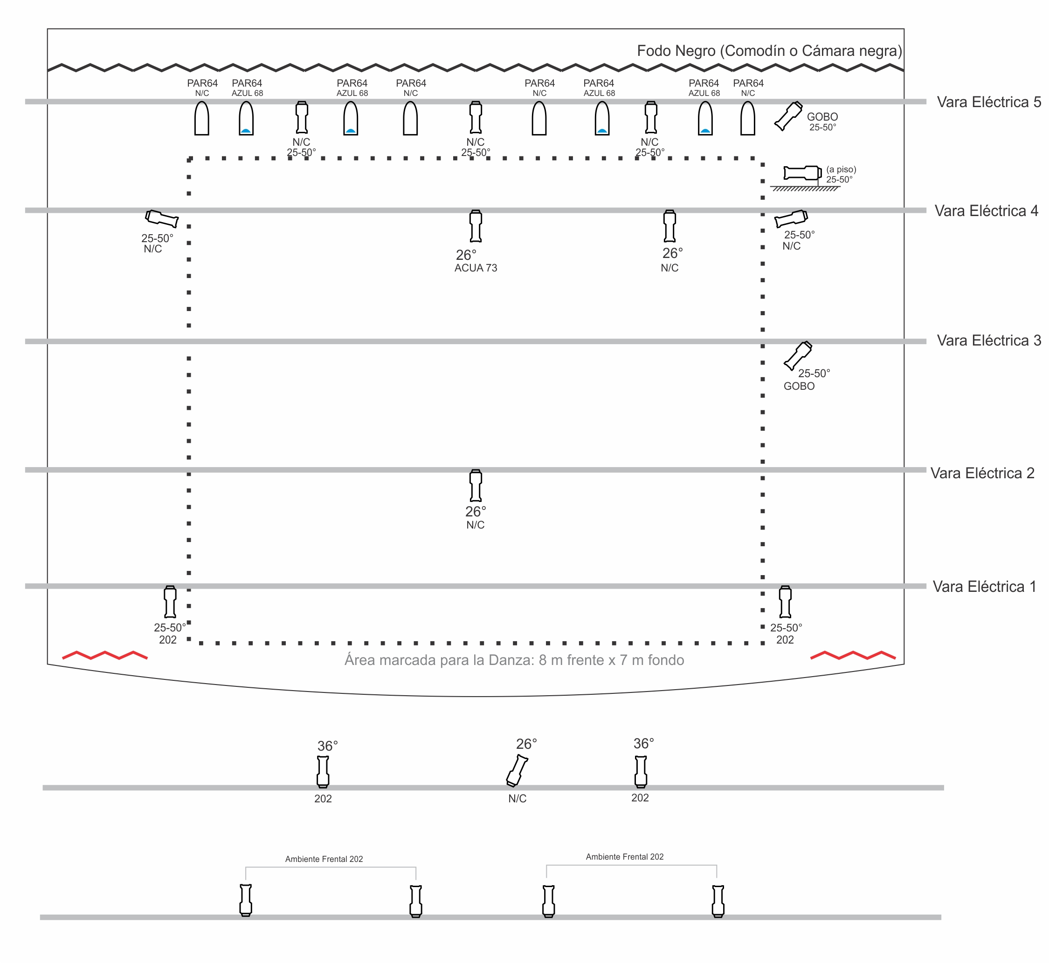

10 ELLIPSOIDAL 25-50° (1 ON THE FLOOR)
4 ELLIPSOIDALS 26°
2 ELLIPSOIDALS 36°
8 PAR 64 (BACKLIGHTS)
FRONTAL WASH 1 elipsoidal on stage floor (25-50°)
4 terms of side lights: floor, middle and top
Top Wash: Red, Blue and Green

STAGE PLOT:
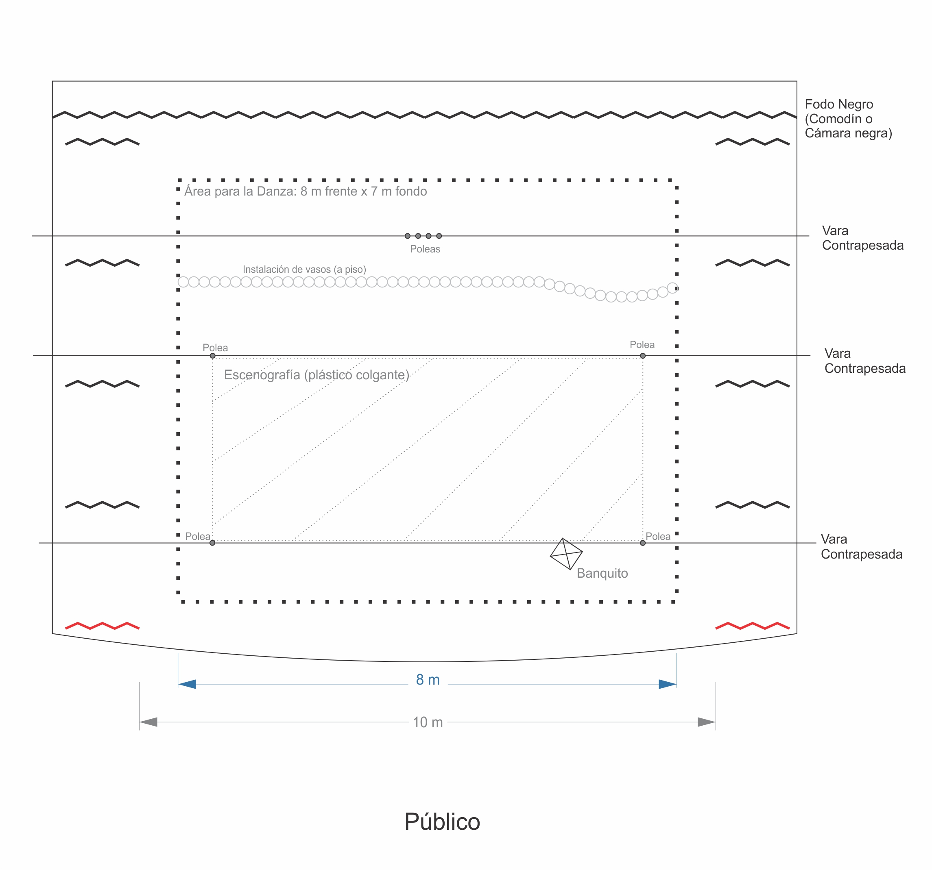

PLANO DE AUDIO:
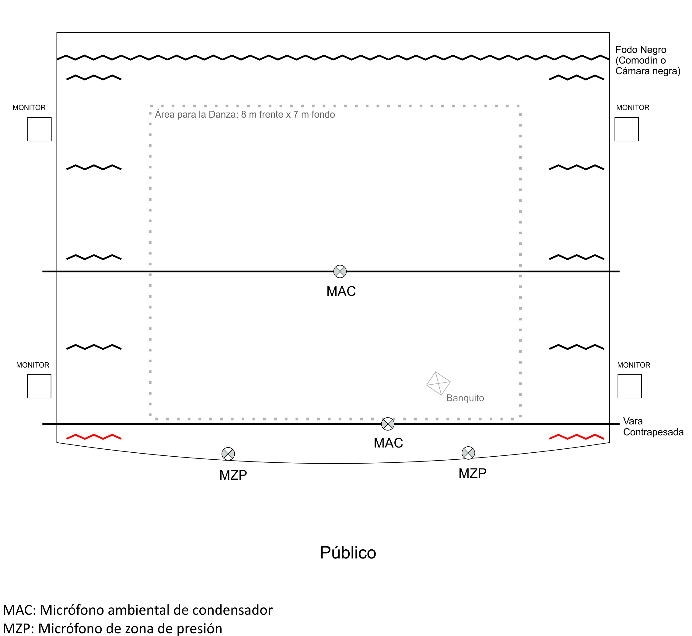

TOURING INFORMATION / PEOPLE TRAVELING:

FULL OFFICIAL NAME: | CHARGE ON THE TOUR | DATE OF BIRTH
1. José Ángel Arámbula Ochoa | Performer / Director General | 4 OCT 1973
2. Henry Torres Blanco | Director Artístico | 1 MARCH 1974
3. Renata de la Cruz Monteón | Performer | 12 JUNE 1996
4. Ilse Karmina Meza Gómez | Performer | 27 NOV 1990
5. Raúl Francisco Osuna Zamora | Performer | 7 JULY 1994
6. Leo Aldair Arroyo Huerta | Performer | 4 FEB1999
7. Sajid Osvaldo Rivas Ochoa | Performer | 09 MARCH 1987
8. Harold Albert García Sandoval | Tech Coordinator and Stage Designer | 8 OCT 1985

ROOMING LIST
4 DOUBLE BEDROOMS
1. | Henry Torres Blanco  Harold García Sandoval
2. | José Ángel Arámbula Ochoa  Sajid Osvaldo Rivas Ochoa
3. | Raúl Francisco Osuna Zamora  Leo Aldair Arroyo Huerta
4. | Ilse Karmina Meza Gómez  Renata de la Cruz Monteón

CARGO:
8 standar suitcases, (20 kg luggage per persona).
1 extra burden 40x40x50 cm / 15 kg

Vista Frontal:
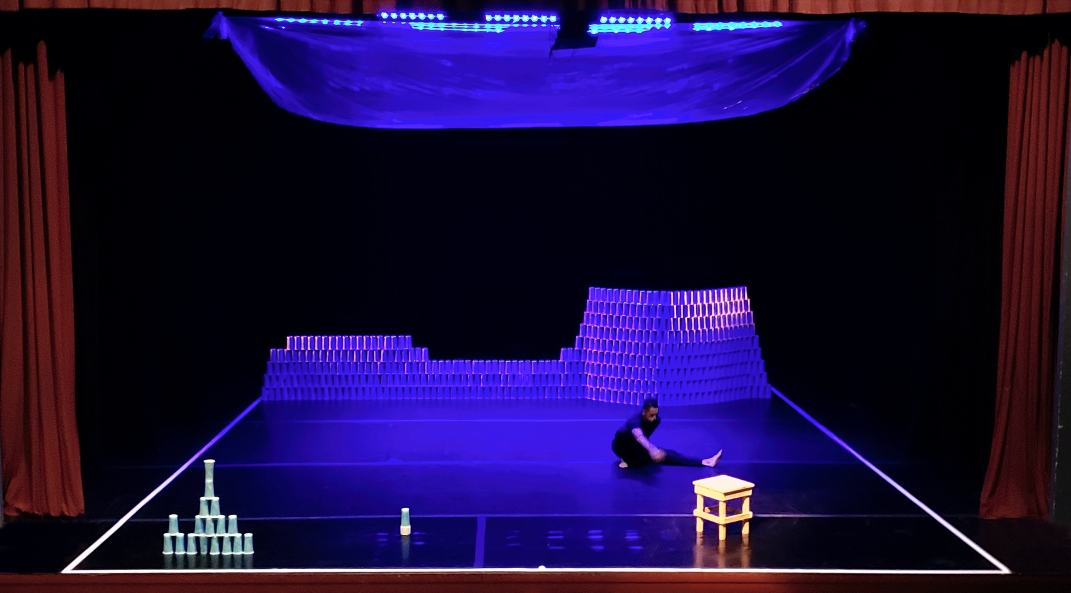

Escenografía en acción:
